PROGRAM1 (i):

import java.io.\*;

import java.util.Scanner;

public class triangle{

public static void main(String[] args){

Scanner scan=new Scanner(System.in);

int n=scan.nextInt();

for(int i=1;i<=n;i++){

for(int j=0;j<i;j++){

if((i+j)%2==0){

System.out.print("0");

}

else

System.out.print("1");

}

System.out.println();

}

}

}

OUTPUT:

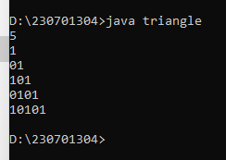

PROGRAM1(ii):

import java.util.Scanner;

public class pattern{

public static void main(String[] a){

Scanner scan=new Scanner(System.in);

int n=scan.nextInt();

for(int i=n;i>=1;i--){

for(int j=1;j<=i;j++){

System.out.print(j);

}

System.out.println();

}

}

}

OUTPUT:

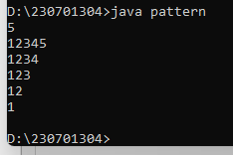

PROGRAM2:

import java.util.Scanner;

import java.io.\*;

public class week{

public static void main(String[] args){

Scanner scan=new Scanner(System.in);

String n=scan.nextLine();

switch(n){

case "Monday":

case "Tuesday":

case "Wednesday":

case "Thursday":

case "Friday":

System.out.println("It's a weekday");

break;

case "Saturday":

case "Sunday":

System.out.println("It's a weekend");

break;

default:

System.out.println("Invalid Input");

break;

}

}

}

OUTPUT:

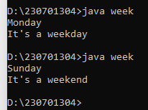

PROGRAM 3:

import java.util.Scanner;

import java.io.\*;

public class strong{

public static void main(String[] args){

Scanner scan=new Scanner(System.in);

int n=scan.nextInt();

int temp=n;

int sum=0;

while(n>0){

int d=n%10;

int fact=1;

for(int i=1;i<=d;i++){

fact=fact\*i;

}

sum=sum+fact;

n/=10;

}

if(sum==temp){

System.out.println("Strong Number");

}

else

System.out.println("Not Strong Number");

}

}

OUTPUT:

